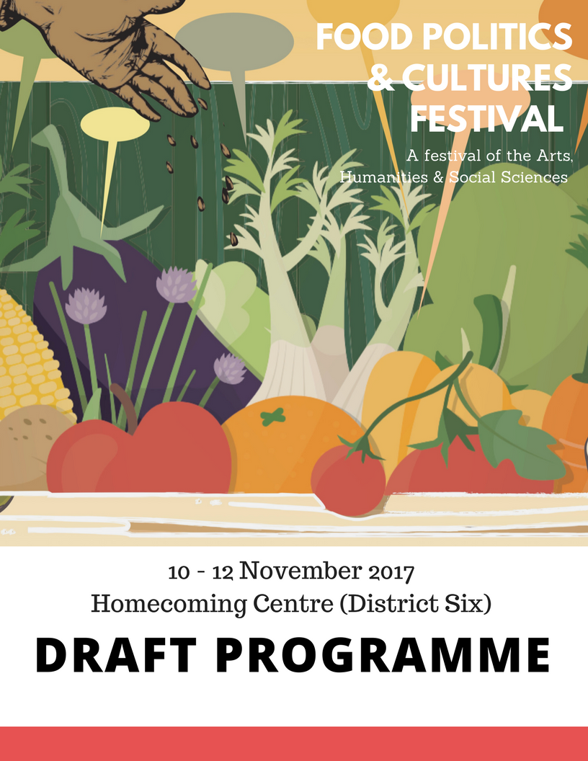

Festival Programme

|  |  |  |
| --- | --- | --- |
|  |  | **Day 1: Friday 10 November** |
| Time | Venue | Programme |
| 9h15 – 9h45 | Reception area | Registration and Tea |
| 10h00 – 11h30 | Tafel | **Opening discussion: Food talk across boundaries**  **Chair:** Donna Andrews  Gabeba Baderoon (Penn State University)  Desiree Lewis (University of the Western Cape)  Tina Smith (District 6 Museum)  Moenieba Isaacs (PLAAS, University of the Western Cape)  Reading by Pat Fahrenfort, author of *Spanner in the Works* |
| 11h30 | Reception area | Tea |
| 12h00 – 13h30 | Tafel | **Panel Discussion: Food struggles and agrarian transformation**  **Chair:** Sean Sithole  Vanessa Ludwig (Surplus People’s Project)  Zayaan Khan (Slow Food Youth Movement)  Siviwe Mdoda (Right2Know)  Abedia Davis (University of Stellennbosch)  **Mystica**  **Struggle for food justice and food sovereignty**  **Chair:** Haidee Swanby  Elfrieda Strauss (Seed Knowledge Initiative)  Andrew Bennie (Witwatersrand University)  Jo Hunter-Adams (University of Cape Town)  Remoneilwe Mogatosi (University of the Western Cape) |
| 13h30 – 14h30 | Reception area | Lunch |
| 14h30 – 15h30 | Workshop  Room  Tafel | **Workshop 1: Jam, Jars and Joy: Food, bodies and objects**  **Chair:** Suzall Timm  Denia Jansen (Mawubuye Land Rights Forum)  Suzall Timm (University of the Western Cape)  **Workshop 2: Food and body image**  **Chair:** Shirmeez Samaai  Monique Van Vuuren (University of the Western Cape)  Shirmeez Samaai (University of the Western Cape)  **The scattering Gnanum**  Reading by Pralini Naidoo (University of the Western Cape) |
| 15h30 – 16h00 | Reception area | Tea |
| 16h00 – 17h00 | Tafel | **Book Launch: Cutting Carrots the Wrong Way**    **Chair:** Kobus Moolman (University of the Western Cape)  An Anthology of Poetry and Prose about Food by UWC postgraduate writing students Jolyn Phillips, Kerry Hammerton, Musa Khanyile, Sindiwe Magona and others, edited by Kobus Moolman (published by uHlanga Press). |

|  |  |  |
| --- | --- | --- |
|  |  | **Day 2: Saturday, 11 2017** |
| 9h15 – 9h45 | Reception area | Registration and Tea |
| 10h00 -11h00 | Tafel | **Public Lecture: Eating in and out: pasts presents and post-apartheid South Africa**  Angelo Fick (Cultural & Political Analyst, eNCA News) |
| 11h15 – 13h00 | Tafel | **Film screening and discussion: From Earth to plate Nature/Society and the ecological crisis**  **Chair:** Donna Andrews  **The story of Sarah Niemand**  Film directed by Riaan Hendricks  Reading by Jolyn Philips, author of *Tjieng Tjang Tjerries and other stories*  Riaan Hendricks (Multi award winning documentary filmmaker)  Moenieba Isaacs (PLAAS, University of the Western Cape)  Donna Andrews (University of the Western Cape) |
| 13h00 – 14h15 | Reception area | Lunch |
| 14h15 – 16h00 | Tafel  Workshop space | **Round table 1: Understanding Foodscapes and Foodways**  **Chair:** Lynn Mafofo  Rifqah Tifloen (Calabash Trust)  Brittany Kesselman (Witwatersrand University)  Kesa Hema (University of Johannesburg)  Olipa Phiri (University of the Western Cape)  Chumani Mtshixa (University of the Western Cape)  Loubie Rusch (Making KOS)  **Round table 2: Politics of the Belly**  **Chair:** Thembelihle Bongwana  Busiso Moyo (University of the Witwatersrand)  Bognan Valentin (Université Félix Houphouët Boigny)  Elsa Vogts (Stellenbosch University)  Mary Hames (University of the Western Cape)  Shari Daya (University of Cape Town)  **Demonstration:** Politics of Stomach, Kina Mkize (University of the Witwatersrand) |
| 16h00 | Reception area | Tea |
| 16h30 – 18h00 | Tafel | Saint Marks Marimba Band |
| 18h00 – 20h00 | Gallery | **Art Exhibition Opening** |

|  |  |  |
| --- | --- | --- |
|  |  | **Day 3: Sunday, 12 November** |
| 9h30 – 10h00 | Reception area | Registration and Tea |
| 10h00 – 11h00 | Tafel | **Cultural Performance on food, eating and Everyday Life** |
| 11h00 – 12h00 | Workshop | **Round table: Nurturing new food systems**  Comrade Carrot (Wynberg Organic Urban Farm)  Xolisa Bangani (Ikhaya Garden)  Chuma Precious Mgcoyi (Tyisa Nabanye)  Nazeer Sonday (Phillipi Horticulture Area Food & Farming Campaign) |
| 12h00 - 13h30 | Tafel | **Interactive discussion: Cooking, memory and the imagination**  Tina Smith in Conversation with others about women’s recipes in District Six |
| 13h30 – 14h15 | Reception | Extended Lunch |
| 17h30 – 18h00  18h00 – 20h00 | Tafel | Join us for a glass of wine before the play  **Play by Mike van Graan: Another one’s bread**  A dark comedy about funerals, feeding and faking, featuring Faniswa Yisa, Chuma Sopotela, Motlatji Ditodi and Awethu Hleli, directed by Pamela Nomvete. |

Draft 8 November 2017 @10h42 AM